# Banko Plates Generator - BP1A

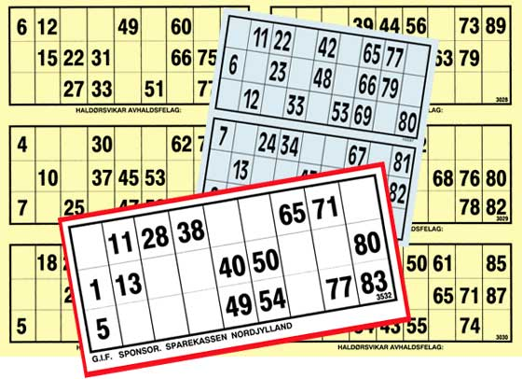Banko (and Bingo) has mo­re than 100 years of history in Denmark. In the old days played re­gularly all over the country. Today it is primarily played through the inter­net, although many still prefer to play it together with other people.

Figur 1 http://www.epbanko.dk/Bankoplader

In this exercise you must **design** and **implement** a generator 0f plates to play banko on. And produce a set of at least 50 different plates.

NOTE :

that the twin~exercise BankoPlayGenerator_BP1B must use your pro­duced plates. So you must adherer your output to the agreement with another development team

Remember :

one class ~ one responsibility

EXERCISE 1

Design the Banko Plate Generator (see the rules below) using the neces­sary and known UML tools.

During this design phase plan together with the development team of Exercise BP1B the format of the generated Banko Plates, so they can use it. The result of this must be a written description – a contract.

EXERCISE 2

Implement the code according to your own design and to your agreement with the other development team.

Remember to implement equals() and toString().

EXERCISE 3

Test it !!!

RULES FOR BANKO PLATES

Every produced Banko Plate has its own unique number for identification.

The basis plate has 3 rows and 9 columns (see below).

You must insert 15 different random numbers from either of the intervals

[ 1 – 89 ] or [ 1 – 90] (your choice)

Each set of numbers on the Banko Plate must be unique too.

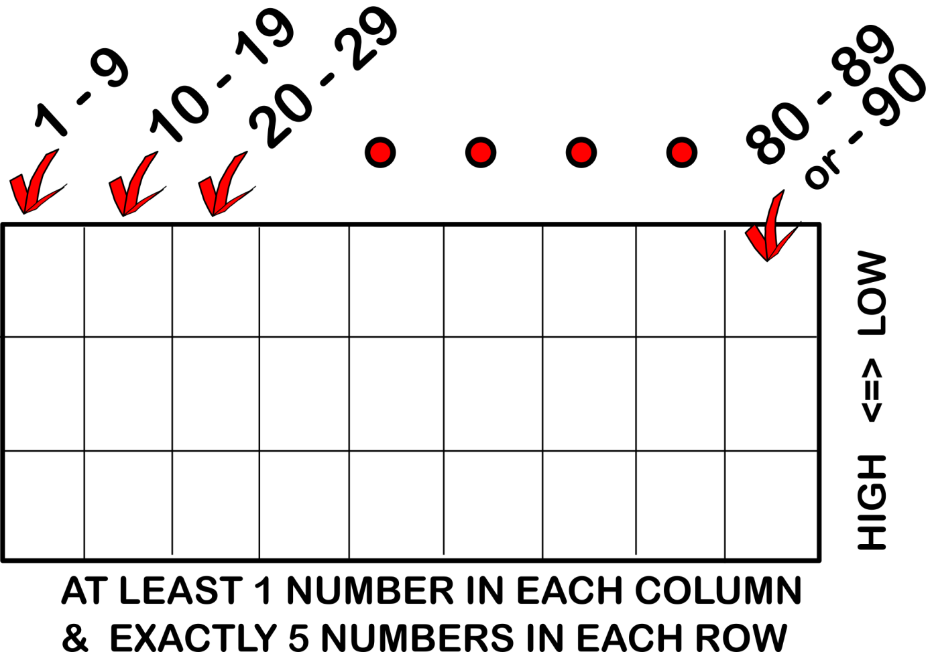

Example :

